Minibus Policy
Author’s Name: | Mr. N. Houchen
Date Reviewed | June 2017
Date Ratified by Trust
Signature of CEO
Signature of Chair of Trust

Contents
1.0 Introduction 3
2.0 Named Vehicle Holder 3
3.0 Minibus Driver 3
4.0 Minibus Checklist 3
5.0 Journey and Driving Times 4
6.0 Journeys Abroad 4
7.0 Emergency Equipment and Procedures 4
Appendix A - Driving License Requirements 5
Appendix B – Vehicle Checklist 7

Introduction

Driving a minibus puts extra demands on the driver and requires additional skills in order to be able to handle the vehicle safely, particularly if he/she normally only drives a car, or if driving is not their main occupation. A minibus is longer, wider, taller and up to 3 times heavier than the weight of a car, especially when loaded with passengers. As such it: takes further to stop; has slower acceleration and less power for hills or overtaking; is more cumbersome to manoeuvre; and has more body roll, pitch and sway. In addition, the driver takes on the responsibility for the safety of more passengers than normal. Although rare, serious, sometimes fatal accidents have occurred involving minibuses.

Named Vehicle Holder

The named vehicle holder is Mr. Sterling.

The named vehicle holder is responsible for:

- Vehicle log book and tax records.
- Insurance.
- MOT certificate.
- Minibus Section 19 permit.
- Service and maintenance records.
- Register of authorised drivers.

Minibus Driver

Drivers of minibuses have ultimate responsibility for traffic related matters whilst the vehicle is on the highway. This responsibility covers personal driving standards, road worthiness of the vehicle and the behaviour of persons carried as passengers.

Driving Licence requirements are summarised in Appendix A.

Minibus Checklist

Checks must be undertaken each time the vehicle is used and should be undertaken by the driver.
A checklist is summarised in Appendix B.

Journey and Driving Times

It is recommended that the maximum continuous period of driving should not exceed 2 hours and should be followed by a minimum break of 10 minutes every 2 hours.

Unless lower limits are in force, the following maximum speeds must not be exceeded:

- Motorways - 70mph
- Dual Carriageway - 60mph
- Other Roads - 50mph

Journeys Abroad

The regulations that govern journeys outside the UK depend upon the country or countries being visited (including those which are simply passed through) and the type of trip being undertaken. Section 19 Small Bus Permits are not valid abroad. Therefore, the driver must hold a PCV licence if any payment is made by passengers for the trip i.e. where it constitutes ‘Hire and Reward’. This means that a PCV licence is required for any foreign journey where, had the journey been made in the UK alone, a Section 19 Small Bus Permit would be required.

Emergency Equipment and Procedures

Regulation 42 and Schedule 7 of the Road Vehicles (Construction and Use) Regulations 1986 specify that every minibus must carry a British Standard fire extinguisher of water or foam with a minimum test rating of 8Aor 21B. If passengers in wheelchairs are being carried, the minibus should carry two fire extinguishers, one of which is kept in the passenger compartment. Drivers and passenger assistants should be trained in their use.

The regulations also specify that a suitable, clearly marked first aid box is kept readily available and in good condition.

The driver and passenger assistant(s) must know where the emergency equipment is kept in the vehicle and how to use it. The driver should check all the items are present before each trip.
Every time an item is used the driver should inform the operator, who should ensure the item is replaced or re-filled.

Before setting off, the driver must make sure all passengers know the procedures for an emergency, such as evacuation if a fire starts, or the vehicle breaks down. This should form part of the risk assessment for the journey.

In case of emergency, as quickly and safely as possible, the driver should:

- Stop the vehicle well over to the side or on the hard shoulder.
- Get everyone out of the vehicle.
- Supervise to keep them in a safe place away from traffic.
- Phone 999.
- Only tackle a fire if it is safe to do so with the extinguisher.

Appendix A - Driving License Requirements

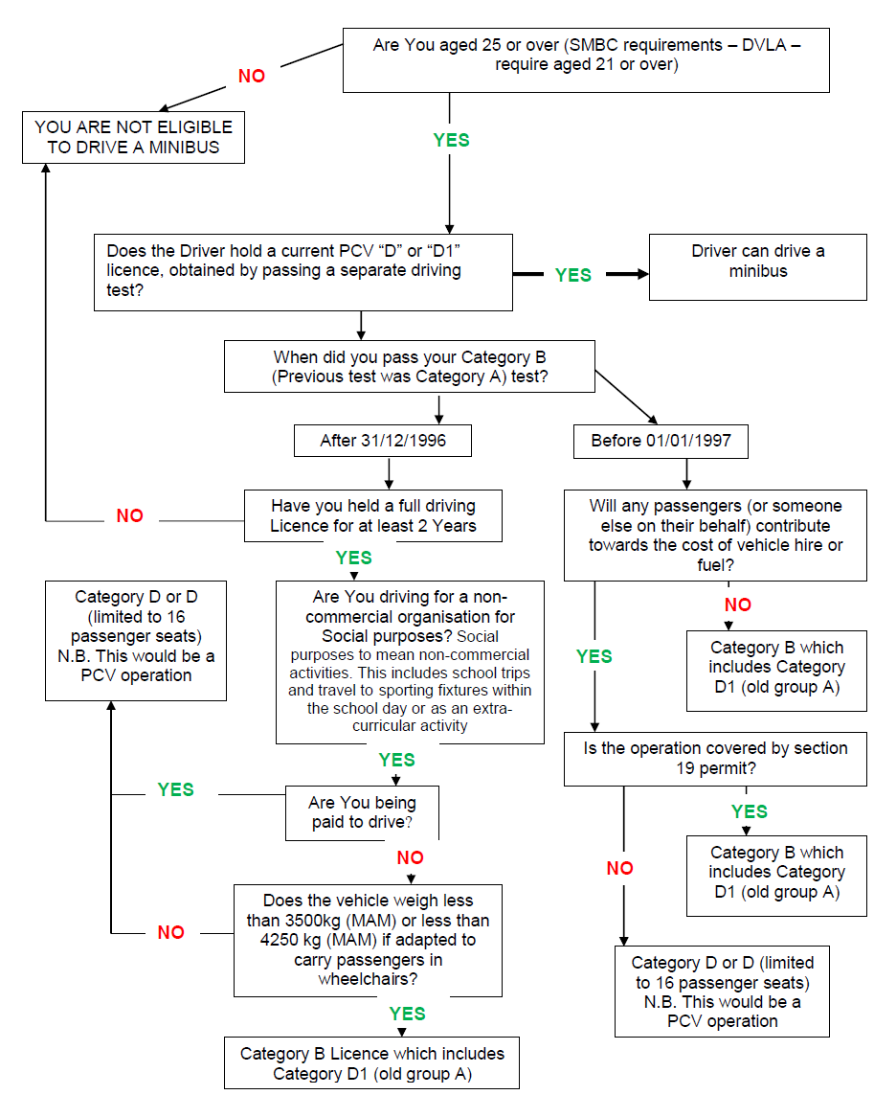

Appendix B – Vehicle Checklist

