|  |
| --- |
|  |
| **Student Leadership Team** |
| Handbook |

|  |
| --- |
| May 2017 |



# Message from the PRINCIPAL

It gives me great pleasure to welcome you to the Student Leadership Team.

Your appointment is the embodiment of all that is exemplary about the Academy and affirms your personal qualities that made you an outstanding candidate for a position on the team.

I sincerely hope that you enjoy the position and the responsibility that comes with it.

I look forward to working with you throughout the course of the year and seeing you grow and develop into the role.



Mr. N. Houchen

Principal

# Structure of Student Leadership Team

**Student Leadership Team 2017 - 2018**

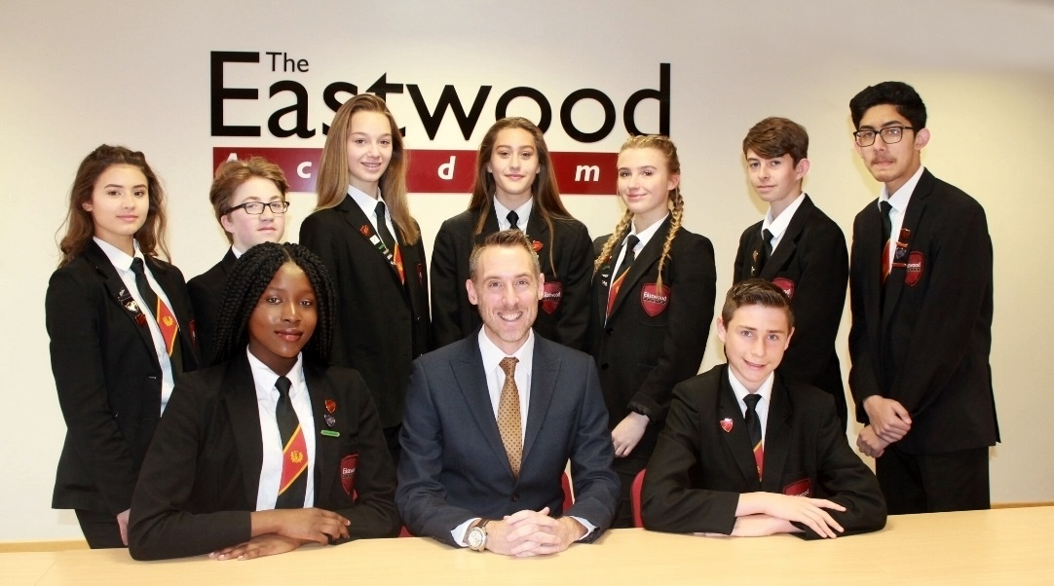

BR: Georgia (DHG), Alex (SP), Josie (SP), Evie (SP) Megan (SP) Harry (SP) Momin (DHB)

FR: **Adanna (HG),** Mr Houchen (Principal) **Sam (HB)**

# Roles and responsibilities

Prefects play a vital part in the running of The Eastwood Academy; assisting and supporting both staff and pupils.

The main role of a Prefect is categorised into:

* Maintaining discipline
* Helping staff
* Supporting younger pupils
* Organising events

**It is important that you, and the Academy are very clear about your role and responsibilities. In performing your duties as Prefects, you will be expected to:**

* To act as a role model for pupils and promote the ethos of the school
* To maintain an atmosphere of friendly cooperation, discipline and unity in the Academy
* To wear the correct uniform at all times
* Observe the Academy rules at all times
* To help ensure Academy rules are adhered to by pupils
* Maintain an excellent attendance record
* Maintain excellent academic and behavioural standards
* Be punctual for your duties
* Be positive and enthusiastic
* Be cooperative, helpful, well-mannered, trustworthy, and responsible
* Be respectful toward teachers, peers, and the Academy environment
* Display leadership qualities: confidence, initiative, problem solving skills
* Be willing to take on extra responsibility
* Be able to work independently and complete tasks without supervision
* Be a good ambassador for the Academy
* To report any issues to the Head Boy or Head Girl
* To fulfil the specific responsibilities
* To attend all meetings as required
* To liaise and collaborate with each other as a team
* To be an approachable Prefect to whom pupils can come to for assistance or support
* To serve as mentors for younger pupils
* To help organise school events
* To attend Academy functions when required

**Additional Duties**

All prefects are required to perform duties either at break time or lunchtime. It is important that you know where and when you are on duty. It is essential that you turn up for your duties on time, carry out your duty to the best of your ability and not leave until the end of your duty time.

If you know in advance that you are unable to do your duty, it is your responsibility to inform your team leader to arrange cover. Prefects that persistently fail to turn up to their duties will forfeit their right to be a prefect.

# Job Descriptions

All prefects will have general responsibilities as part of the team, which includes break and lunchtime duties and daily team duties. Throughout the year there will be other roles prefects will be expected to fulfil, including supporting various functions such as Commendation Evening and Open Evening.

In addition to the roles and responsibilities outlined on the previous page, Senior Prefects will be required to perform additional duties.

**Senior Prefect Job Descriptions**

|  |  |
| --- | --- |
| **Post** | **Job Description** |
| **Head Boy and Girl** | * Prepare duty rotas and make sure that they are carried out * Represent the Academy at various functions * Be prepared for special duties, including speeches * Discover and understand the views of the students and represent them to the Head and Staff e.g. by chairing Student Voice meetings * Hold regular Prefects’ meetings * Be involved with the organisation of whole Academy events * Maintain notice board in reception area |
|  |  |
| **Deputy Head Boy and Girl** | * Shadow the Head Boy and Girl * Be prepared to deputise and support them in all of the above duties, as required * Help with rotas and monitoring that duties are being done * Write the minutes of meetings and circulate them |
|  |  |
| **Senior Prefects** | * Make up the Senior Prefect Team * Represent the Academy at various functions * Be responsible for duty teams on a daily basis |

# developing future Leaders

You have been chosen as a prefect based on certain skills and qualities that you have or the potential that has been recognised in you. You will also gain additional skills within your prefect role, developing the skills and qualities of leaders.

**The Basic Skills of Outstanding Leadership**

**Integrity**

Integrity is about being honest and having strong moral principles. It means treating others as you would wish to be treated. Integrity is about respecting others and developing trust.

**Communication**

In the Student Leadership Team, communication is vital both between leaders and followers, but also across the whole team. Clear communication facilitates organisation and discipline. It helps to motivate and inspire, informing members, whilst also seeking out information to build a strong team.

**Relationships**

Developing relationships is essential for communication and building strong teams. Interpersonal relationships need to be nurtured to ensure all members ensue the ethos of the team.

**Persuasion**

The ability to influence others and guide them in another direction is an essential skill in leadership. It directly correlates with the trust that people put in you and the strength of your communication and relationship skills.

**Adaptability**

A strong leader will understand the importance of being flexible and willing to change direction to ensure the success of the strategy, taking this all in their stride. The sign of a good leader is someone who does not stay still, but is willing to embrace change and see it as opportunity.

**Teamwork**

The Student Leadership Team is a team of Prefects, linking in to the wider Academy Prefect system. Each member will have different skills, personalities and strengths to bring to the role. It is essential to the success of the team that everyone understands that not one person can do it all, it is teamwork that makes the system a success. A leader must know how to build and nurture such a team.

**Decision-making**

A leader must be able to process information, identify what is relevant, reflect and then take actions based on that decision. Making decisions too quickly or too slowly will impede your leadership effectiveness.

# Prefect contract

Prefects have to sign a contract and a copy of this will be kept by Mrs. Niner. If any prefect fails to adhere to the contract, their badge and status will be taken away.

**Code of Conduct for The Eastwood Academy Prefects**

I accept my badge as a prefect at The Eastwood Academy for this year. I agree to carry out the following duties and responsibilities.

* To maintain high standards of behaviour and conduct and to wear my prefect's badge with pride.
* To obey the Academy rules in their entirety and without question.
* To take an active part in Academy functions, helping and organising whenever I am asked.
* To lead by example.
* To help new pupils, especially new pupils during their introduction to the school.
* To assist visitors to school at all times by being polite, friendly, and courteous.
* To maintain a high standard of cleanliness and tidiness throughout the school.
* To perform designated duty rotas.

I, _________________________________ have read and understood the Prefect's Code of Conduct and I agree to carry it out to the best of my abilities.

___________________ _______________________

School Prefect Date